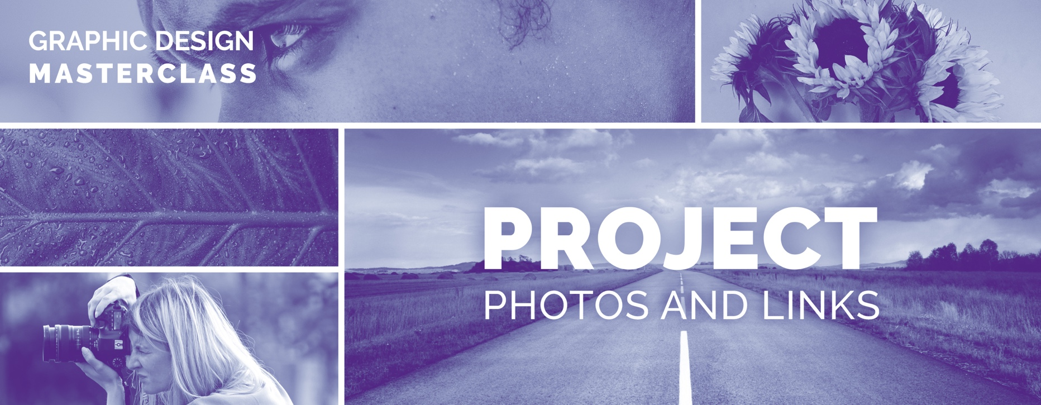
Make sure to check out the Resources Guide PDF that contains several pages full of helpful resources for graphic designers!
All of these can be found in the Course Resources Guide folder in the downloadable .ZIP file.
I wanted to provide links to all of the photos used in the class project examples and projects, so you can follow along with me if you learn best by doing instead of just watching.

Most of the photos I use for the project-based parts of this class can be found on Pexels.com. I located specific links, so you can go right to the photo for that particular project.
Some photographers or owners of these free to use photos occasionally remove a photo, so if you see a (alternative photo) tag, I found a photo that closely resembles the removed photo. Remember, for some layout projects, feel free to experiment with your own chosen photos from pexels.com, unsplash.com, pixabay.com or other photo resources to craft something that is truly your own.

There are several lessons with downloadable resources, make sure to look out those for specific project resources in the .Zip file that was supplied with the course.
 Photoshop Section

Photoshop introduction Project - Project One - Shoe
https://www.pexels.com/photo/close-up-photo-of-sneakers-2529147/

Photoshop introduction Project - Project Two - Girl with Green Dress
https://www.pexels.com/@marcelo-chagas-861665

Gradients and Duotones Lesson

Man dancing - https://www.pexels.com/photo/man-break-dancing-on-street-1510540/

Sunglasses woman
https://www.pexels.com/photo/woman-posing-for-photo-shoot-1689731/

Cutting objects out

Coffee cup
https://www.pexels.com/photo/apple-device-beverage-black-coffee-cafe-551993/

Man, on beach
https://www.pexels.com/photo/man-wearing-black-zip-up-jacket-near-beach-smiling-at-the-photo-736716/

Color change
Red hair woman
https://www.pexels.com/photo/upside-down-photo-of-a-woman-1821095/

Woman pink dress
https://www.pexels.com/photo/woman-standing-sideways-2065195/

Content Aware Lesson
Woman on Blue Wall
https://www.pexels.com/photo/woman-standing-against-teal-wall-near-sconce-1661487/

Spot Healing Brush Tool Lesson
Scrabble Letters
https://www.pexels.com/photo/words-text-scrabble-blocks-695571/

Layering Mask Lesson
https://www.pexels.com/photo/adventure-boy-girl-idyllic-450441/

Non-destructive Editing
Blond Woman
https://www.pexels.com/photo/closeup-photo-of-woman-on-blue-textile-157967/

Non-destructive Editing part 2
B&W woman photo
https://www.pexels.com/photo/woman-face-157661/

Photoshop Projects

The following two photoshop projects are taken from my Project Based Graphic design course, Master Graphic Design & Software with Practical Projects. I thought these two projects would be great compliments with the Photoshop tools we have learned so far.

YouTube Thumbnail Project
There is a YouTube Thumbnail template that can be found the downloadable .zip file you downloaded in the course guide lesson of the course that might be helpful when sizing and creating your thumbnail. It can be located in the Photoshop Section Folder.
Woman crossing arms
https://www.pexels.com/photo/photography-of-a-beautiful-woman-smiling-1024311/

New York
https://www.pexels.com/photo/statue-of-liberty-2179602/

Paris
https://www.pexels.com/photo/eiffel-tower-2082103/

Book Design Project
There is a complete photoshop template for the book cover that is downloadable in the first lesson of this project that might come in handy when learning how templates work.

Roses
https://www.pexels.com/photo/red-roses-1187079/

Great Blog Post About Book Sizes
https://blog.reedsy.com/standard-book-sizes/

A great place to find Photoshop Layer Styles
Just unzip the file, open the photoshop file and you can save the layer style in the layer styles panel just like we did in class.
http://www.photoshoplayerstyle.com/

Book Cover Mockup I Used
https://graphicburger.com/hardcover-book-mockup-2/

 ADOBE ILLUSTRATOR
The Tracing Worksheet
You can find this .ai (illustrator) downloadable worksheet in the Resources .zip folder you downloaded in the course guide lesson of the course in the Adobe Illustrator Section Folder. For those with much older versions of Illustrator, make sure you download the OLDER version of this file.
Space Shuttle Logo Project
Space Shuttle - https://www.pexels.com/photo/aircraft-astronaut-business-dusk-355906/

Concert Event Poster
– Various Crowd Shots
https://www.pexels.com/search/crowd/

 INDESIGN

InDesign Basic Training Section
Photos used:

Motorcycle Man
https://www.pexels.com/photo/person-wearing-white-helmet-riding-on-motorcycle-3699259/

Art School Page
Black Backpack
https://www.pexels.com/photo/person-holding-black-backpack-3731256/

Abstract Background
https://www.pexels.com/photo/abstract-painting-1690351/

Magazine Spread (Finding the Right Accessories)
Woman gold earrings
https://www.pexels.com/photo/woman-in-gold-colored-diagonal-earrings-3536991/

Woman gold Necklace
https://www.pexels.com/photo/woman-wearing-gold-chain-bib-necklace-1454168/

Woman Watch
https://www.pexels.com/photo/woman-wearing-beige-crochet-sweater-and-round-white-analog-watch-closeup-photo-1374128/

Crisis Editorial Spread (Text Wrap)

Crisis Spread
https://www.pexels.com/photo/silhouette-of-woman-3862601/

Cookbook Project
Pie (Front Cover)
https://www.pexels.com/photo/raspberry-pie-3065576/

Apple Pie (Front Cover)
https://www.pexels.com/photo/apple-pie-and-raspberry-pie-3065590/

Cupcake
https://www.pexels.com/photo/red-cupcake-2525682/

Brownies
https://www.pexels.com/photo/close-up-photo-of-brownies-3026804/

Berry Tart
https://www.pexels.com/photo/baked-food-close-up-photography-2693447/

Texture Linen
https://unsplash.com/s/photos/linen

FONTS USED
Pacifico
https://fonts.google.com/specimen/Pacifico?query=pac
Open Sans
https://fonts.google.com/specimen/Open+Sans?query=open+sans

Commonly Used Fonts in this Course

A new resource called the “My favorite Fonts” PDF can be found in the Design Theory folder in the course resource .zip file.
Serif Fonts:
Garamond (Old Style)
Palatino (Old Style)
Berkeley (Old Style)
Minion (Old Style

Baskerville (Transitional)

Didot (Didone or Modern)
Bodoni (Didone or Modern)

Letro (Slab Serif)
Rockwell (Slab Serif)
Archer and Archer Pro (Slab Serif)

Sans-Serif Fonts
Helvetica
Gill Sans
Avant Garde (Gothic)
Futura (Geometric)
Raleway (I use this VERY often throughout this course)
Avenir

A wide array of open source free to use fonts are available on Google fonts. You can find many free fonts here to replace some of the paid premium fonts you may find above. https://fonts.google.com

If you have an Adobe Creative cloud subscription, you have free access to 100’s of typefaces and fonts on Adobe fonts at no extra charge.
https://fonts.adobe.com

